Math News

Topic Essential Question: What are ways to think about addition and subtraction?
Add To:
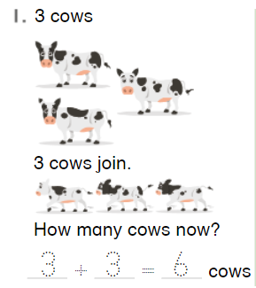

Put Together: 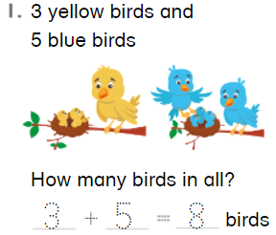

Both Unknown Addends:
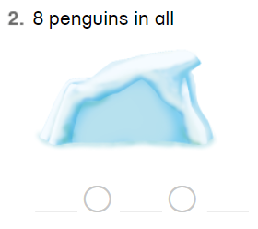

Take From: 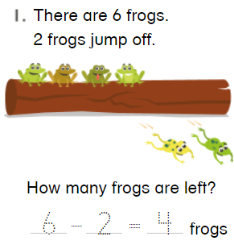

Compare Situations: 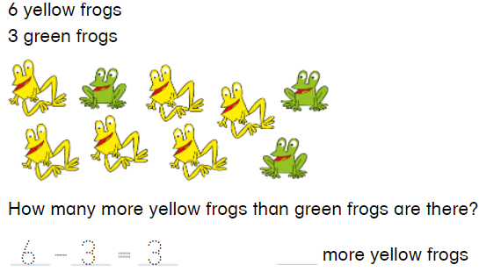

Change Unknowns: 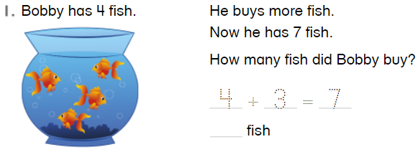
Practice Adding: 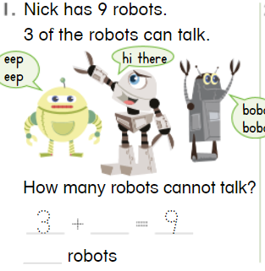

Practice Subtracting: 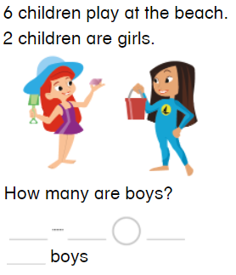
- More
- Compare
- Fewer
- Addend
- Difference
- Minus
- subtract
Standards:
1.OA.A.1 Use addition and subtraction within 20 to solve word problems involving situations of adding to, taking from, putting together, taking apart, and comparing, with unknowns in all positions, e.g., by using objects, drawings, and equations with a symbol for the unknown number to represent the problem.
Vocabulary:
- Add
- Sum
- Equals
- Parts
- Whole
- Equation

